# Emotion Recognition System Installation Manual

Follow the instructions below precisely in order to successfully access and run the Emotion Recognition System. These steps will ensure that you are able to access the application regardless of your familiarity with coding and technical processes. Feel free to copy and paste the commands in Terminal.

### Step 1: Download and Decompress the Application

1. **Download the zip file:**

* Begin the process of downloading the ers_pyqt.zip file by clicking the thumbnail of the Emotion Recognition System application in the Projects page of the portfolio. The portfolio website is [https://www.daoyeyemi.github.io/official_oyeda](https://daoyeyemi.github.io/official_oyeda/).

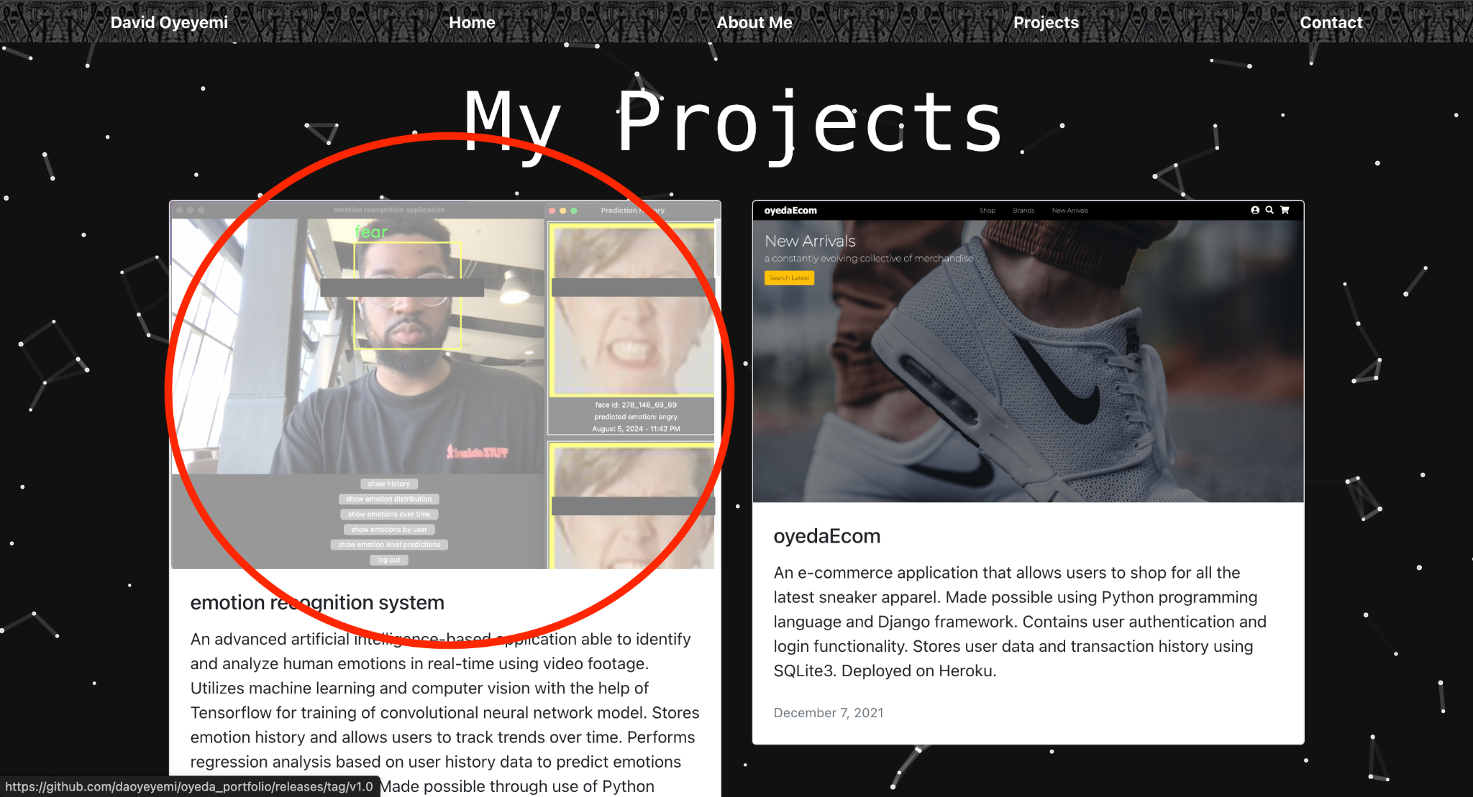

* This will lead you to [*https://www.github.com/daoyeyemi/oyeda_portfolio/releases/tag/v1.0*](https://github.com/daoyeyemi/oyeda_portfolio/releases/tag/v1.0) which contains the downloadable file. Click on the ers_pyqt.zip file option link to gain access to it.

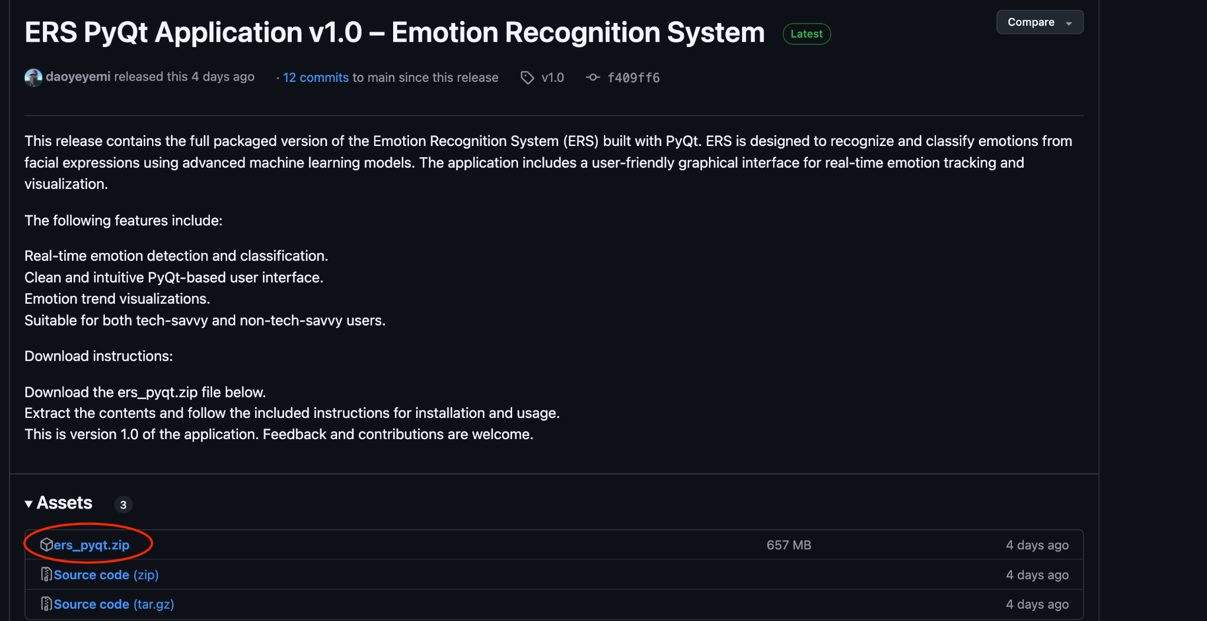

1. **Move the file to your Desktop:**

* Find the downloaded zip file (which would be in your Downloads folder) and **drag it to your Desktop**. This is so the file is easily accessible.



1. **Decompress the file:**

* Right-click on the ers_pyqt.zip file on your Desktop.
* Select **Open with > Archive Utility** (this will unzip the file and create a folder called ers_pyqt on your Desktop).

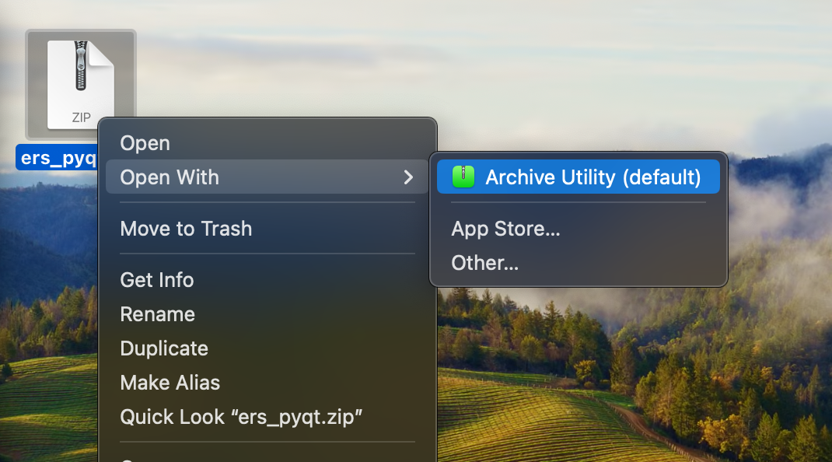

### Step 2: Open Terminal

1. **Find the Terminal application:**

* On your keyboard, press **Command (⌘) + Spacebar** to open and access the Spotlight Search feature.
* Type **Terminal** and press **Enter** when you see the Terminal icon (a black window will open).

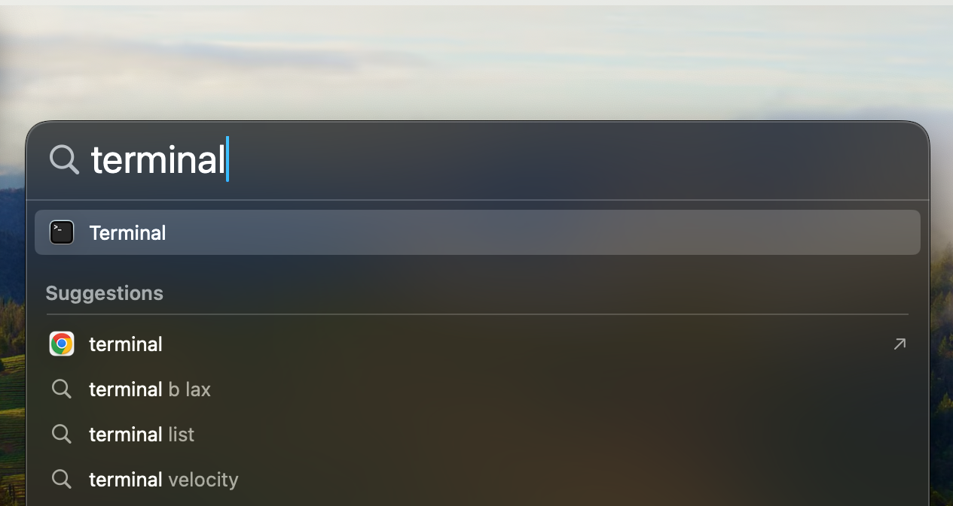

### Step 3: Navigate to the Project Folder

1. **Ensure you’re in the correct location:**

* In Terminal, type the following command and press Enter:

**cd Desktop/ers_pyqt**

* The command will change the directory to the ers_pyqt folder on your Desktop.

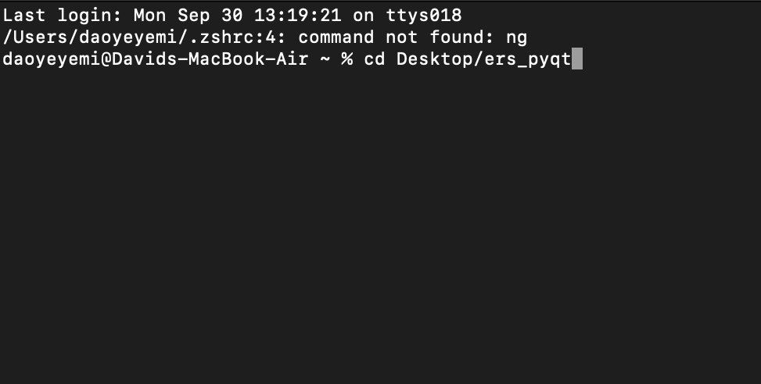

### Step 4: Activate the Virtual Environment

1. **Activate the project’s virtual environment:**

* Type the following command and press Enter:

**source venv/bin/activate**

* This command will activate the environment where all the necessary project files and libraries are stored.
* **Note:** If this step results in an error saying “command not found”, make sure you followed Step 3 correctly or try retyping the command carefully.

### Step 5: Run the Application

1. **Start the Emotion Recognition System application:**

* Type the following command and press Enter:

**python3 main.py**

* This will launch the application.

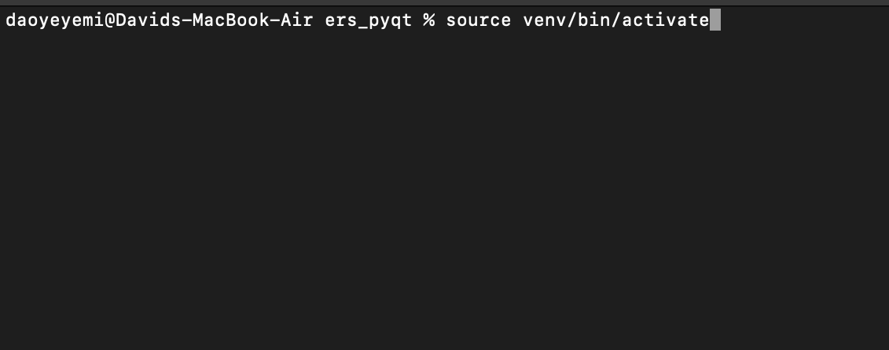

1. **Important Note:**

* If you get an error saying “Python not found”, it means Python 3 is not installed. Follow Step 6 to install it.

### Step 6: Installing Python 3 (if applicable)

If Python3 is not installed on your computer, the application will not run. Install Python 3 by using Homebrew (a package manager for macOS):

1. **Install Homebrew:**

* In Terminal, type the following command and press Enter:

**/bin/bash -c "$(curl -fsSL https://raw.githubusercontent.com/Homebrew/install/HEAD/install.sh)"**

* This will download and install Homebrew. Follow on-screen instructions to complete setup.

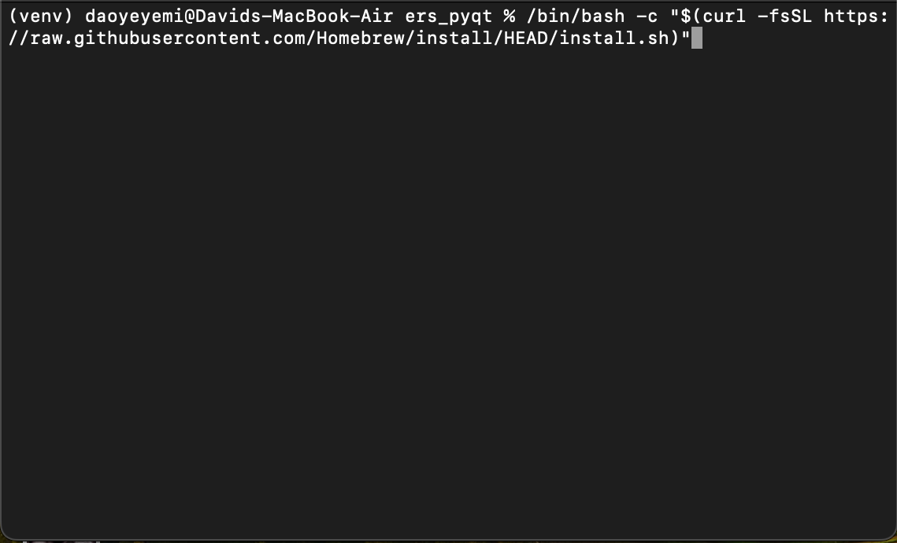

1. **Install Python 3:**

* After Homebrew is installed, type the following command and press Enter:

**brew install python**

1. **Verify the installation:**

* Check if Python 3 has been installed by typing:

**python3 --version**

* You should see a version number, confirming that Python 3 is installed.



### Step 7: Launch the Application

1. **Once Python 3 is installed (if necessary), run the application:**

* Make sure you’re still in the ers_pyqt folder in Terminal and type the following command:

**python3 main.py**

* It may take **5 - 10 minutes** for the application to fully load. Please be patient as the login page appears.

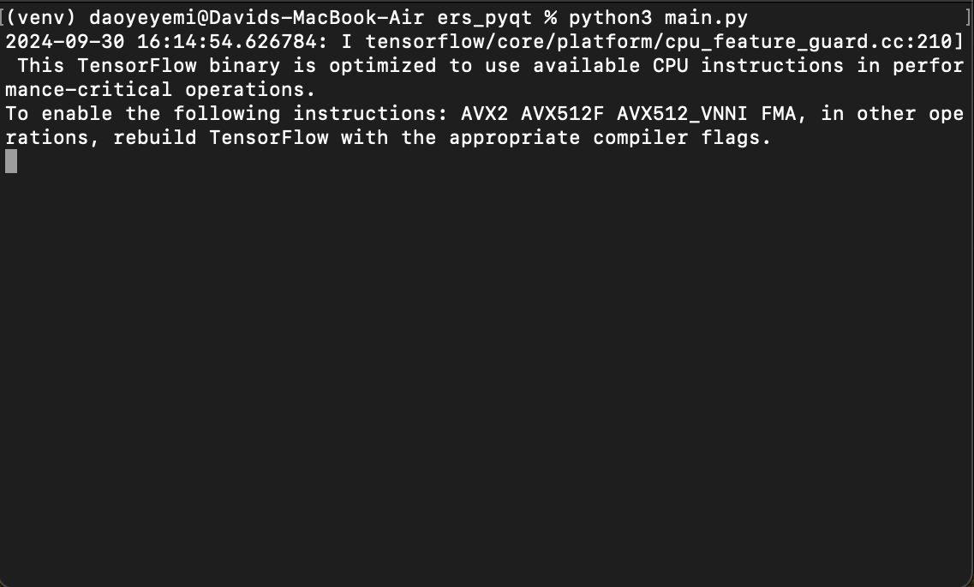

### Step 8: Login and Use the Application

1. **Log in or sign up:**

* If you already have an account, enter your credentials to log in.

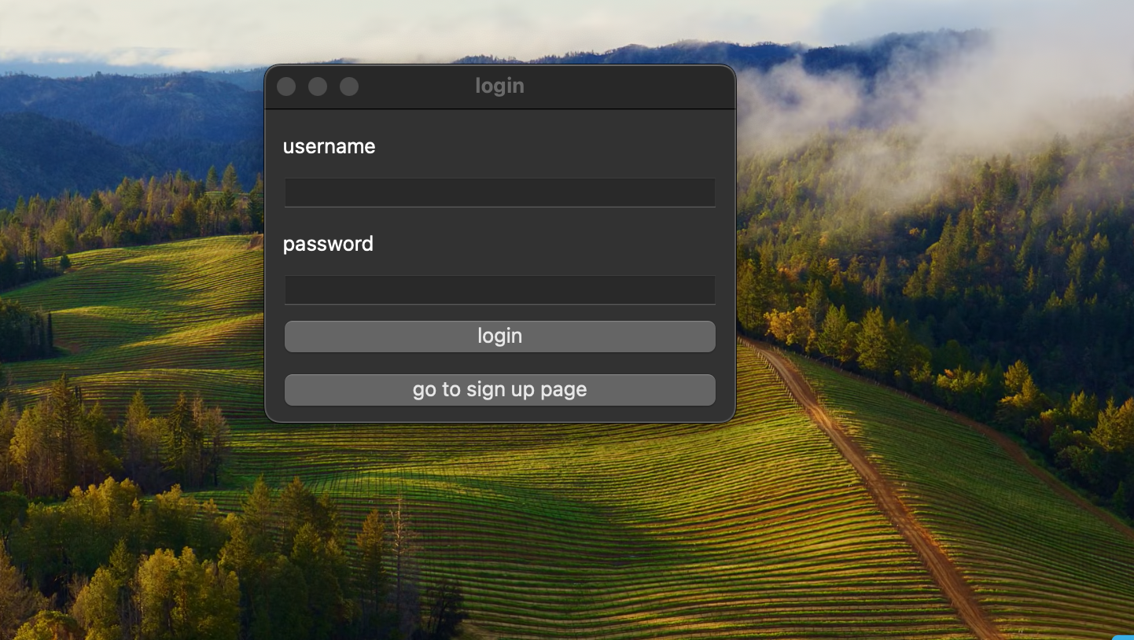

* If you’re new, click **Sign Up** and create an account and then log in.

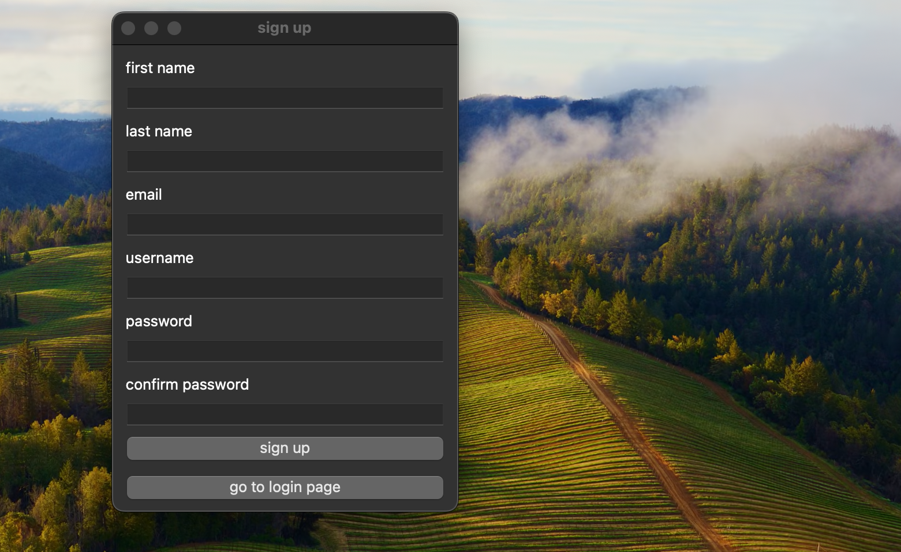

1. **Ensure a suitable environment for accurate emotion recognition:**

* The system uses machine learning and computer vision. For the best results:
  + Make sure you’re in good lighting.
  + Ensure there's a clear distinction between your face and the background

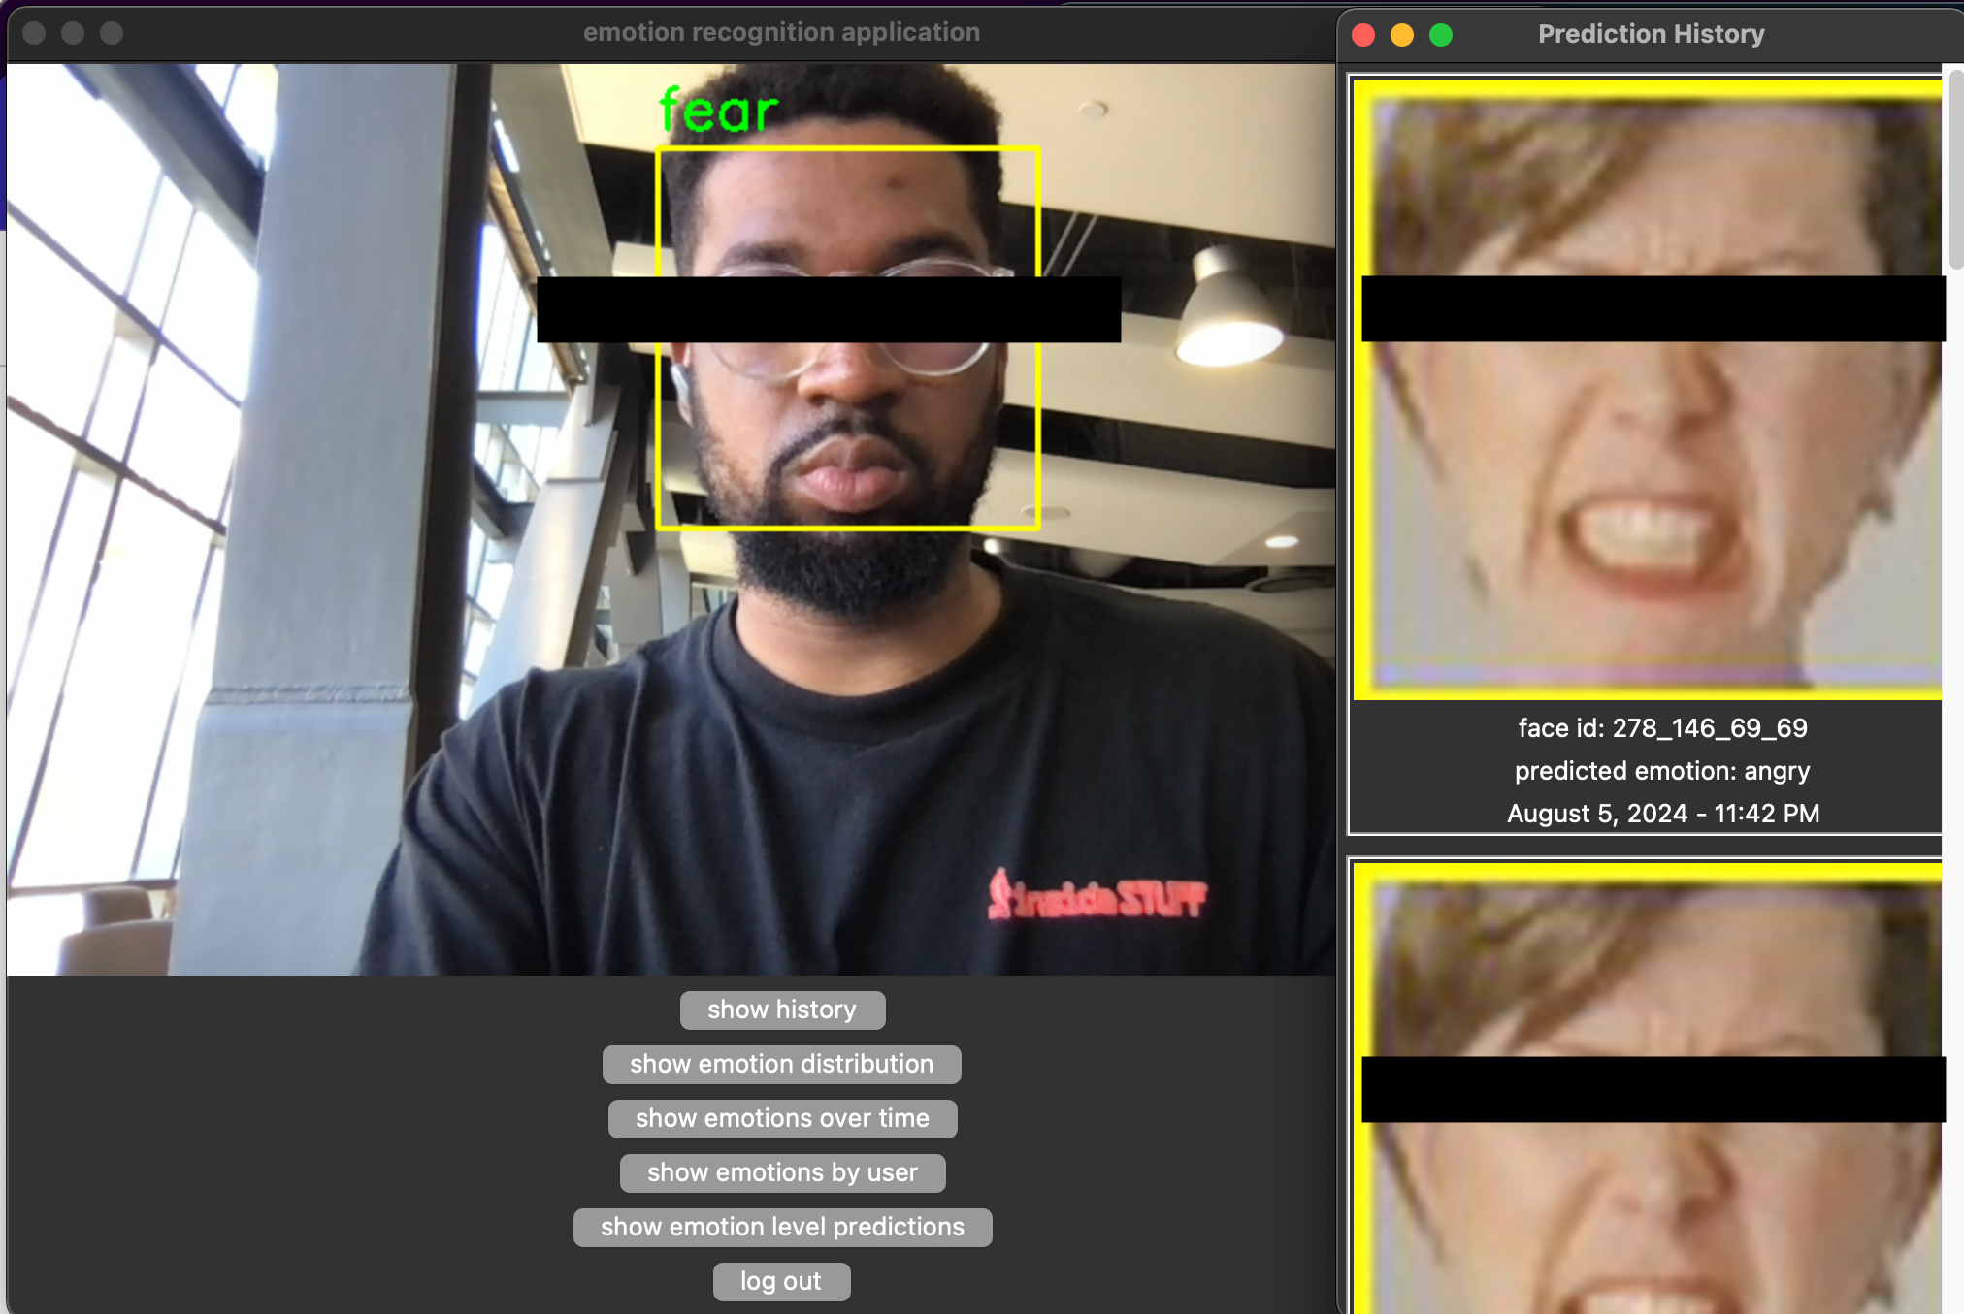

## Troubleshooting

* If the application doesn’t load after running **python3 main.py**, check that you followed all the steps properly, especially activating the virtual environment.
* If you encounter errors related to missing Python or packages, double check that Python 3 and pip are installed correctly.